Ex. No: 2 SQL DDL COMMANDS

**Date: 13/01/22**

**AIM:** To write SQL queries to execute different DDL commands.

Data base created for this exercise is:

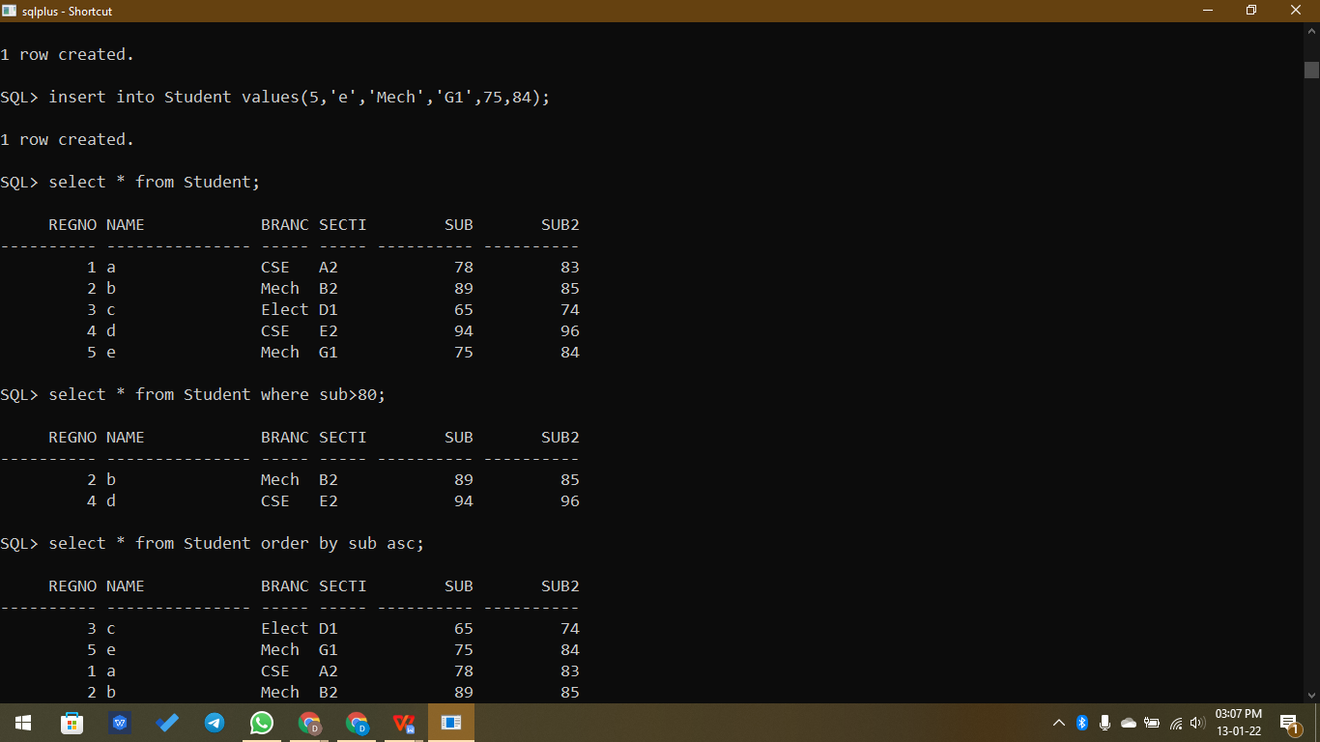

**DDL Commands:**

* **Create -** Used to create a table

**Syntax,**

**CREATE TABLE table_name(field1 datatype1, field2 datatype2, …);**

Example,

SQL> create table student(id int, name varchar(20), marks int);

Table created.

* **Drop -** Used to drop the table

**Syntax,**

**DROP TABLE table_name;**

Example,

SQL> drop table student_details;

Table dropped.

* **Alter -** Used to alter the table (add/delete/modify column, rename the table)

**Syntax,**

**ALTER TABLE table_name add column_name datatype;**

**ALTER TABLE table_name drop(column_name);**

**ALTER TABLE table_name modify column_name datatype;**

**ALTER TABLE table_name rename to new_table_name;**

Example,

SQL> alter table student add branch varchar(5);

Table altered.

SQL> alter table student drop (branch);

Table altered.

SQL> alter table student modify name varchar(50);

Table altered.

SQL> alter table student rename to student_details;

Table altered.

SQL> create table student(id int, name varchar(20), marks int);

Table created.

SQL> insert into student values(1,'a',96);

1 row created.

SQL> insert into student values(2,'b',90);

1 row created.

SQL> insert into student values(3,'c',75);

1 row created.

SQL> insert into student values(4,'d',87);

1 row created.

SQL> insert into student values(5,'e',99);

1 row created.

SQL> select * from student;

ID NAME MARKS

---------- -------------------- ----------

1 a 96

2 b 90

3 c 75

4 d 87

5 e 99

SQL> alter table student add branch varchar(5);

Table altered.

SQL> select * from student;

ID NAME MARKS BRANC

---------- -------------------- ---------- -----

1 a 96

2 b 90

3 c 75

4 d 87

5 e 99

SQL> alter table student drop branch;

alter table student drop branch

*

ERROR at line 1:

ORA-00905: missing keyword

SQL> alter table student drop (branch);

Table altered.

SQL> select * from student;

ID NAME MARKS

---------- -------------------- ----------

1 a 96

2 b 90

3 c 75

4 d 87

5 e 99

SQL> describe student;

Name Null? Type

----------------------------------------- -------- ----------------------------

ID NUMBER(38)

NAME VARCHAR2(20)

MARKS NUMBER(38)

SQL> alter table student modify name varchar(50);

Table altered.

SQL> describe student;

Name Null? Type

----------------------------------------- -------- ----------------------------

ID NUMBER(38)

NAME VARCHAR2(50)

MARKS NUMBER(38)

SQL> alter table student rename to student_details;

Table altered.

SQL> select * from student_details;

ID NAME MARKS

---------- -------------------------------------------------- ----------

1 a 96

2 b 90

3 c 75

4 d 87

5 e 99

SQL> drop table student;

drop table student

*

ERROR at line 1:

ORA-00942: table or view does not exist

SQL> drop table student_details;

Table dropped.

SQL> spool off

**Result:**

Thus the DDL commands are used to modify or manipulate data records present in the customer database tables.